4.39: a) Both crates moves together, so 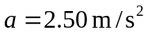
b)
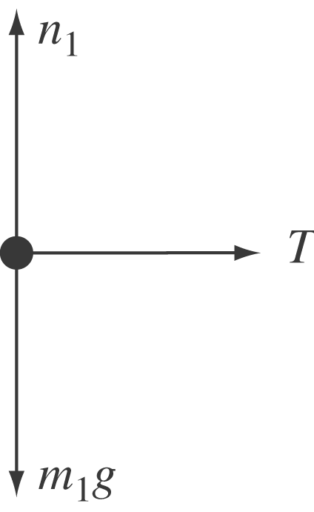
c)
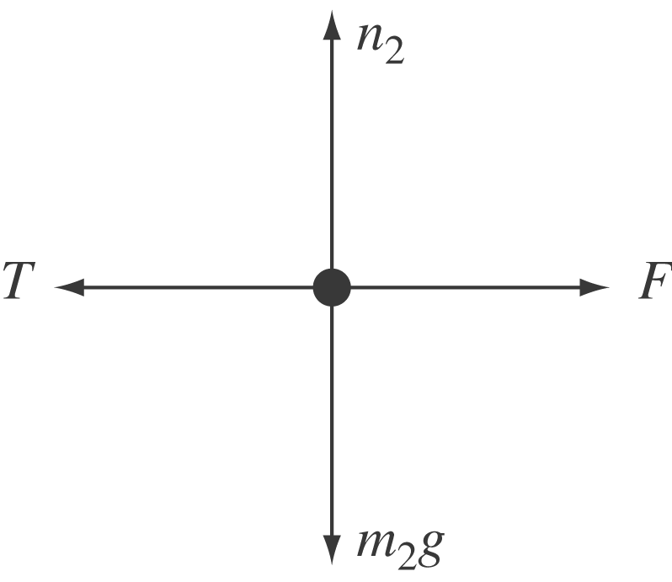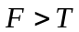 and the net force is to the right, in the direction of .
d) 